FIELD REPORT ON UgIFT ASSET VERIFICATION

KOBKO DISTRICT
- We met the CAO, introduced ourselves and presented the letters from ministry
- The CAO welcomed us and introduced to us the DHO and DEO
- The DHO said only know Chakulia health center III to be receiving ugift assets whereas the DEO knew about Padrombu seed secondary school and Nyakaliso seed secondary school.

PADROMBU SEED SECONDARY SCHOOL
The school did not have records of the UGIFT assets, they only had the inventory records for the school
The headteacher took us through a guided tour through the school showing us the various assets as required

CHALLENGES
There were no clear records kept and the headteacher kept on the assumption that all assets are from ugift

RECOMMENDATIONS
Headteachers should be educated on the importance of record keeping
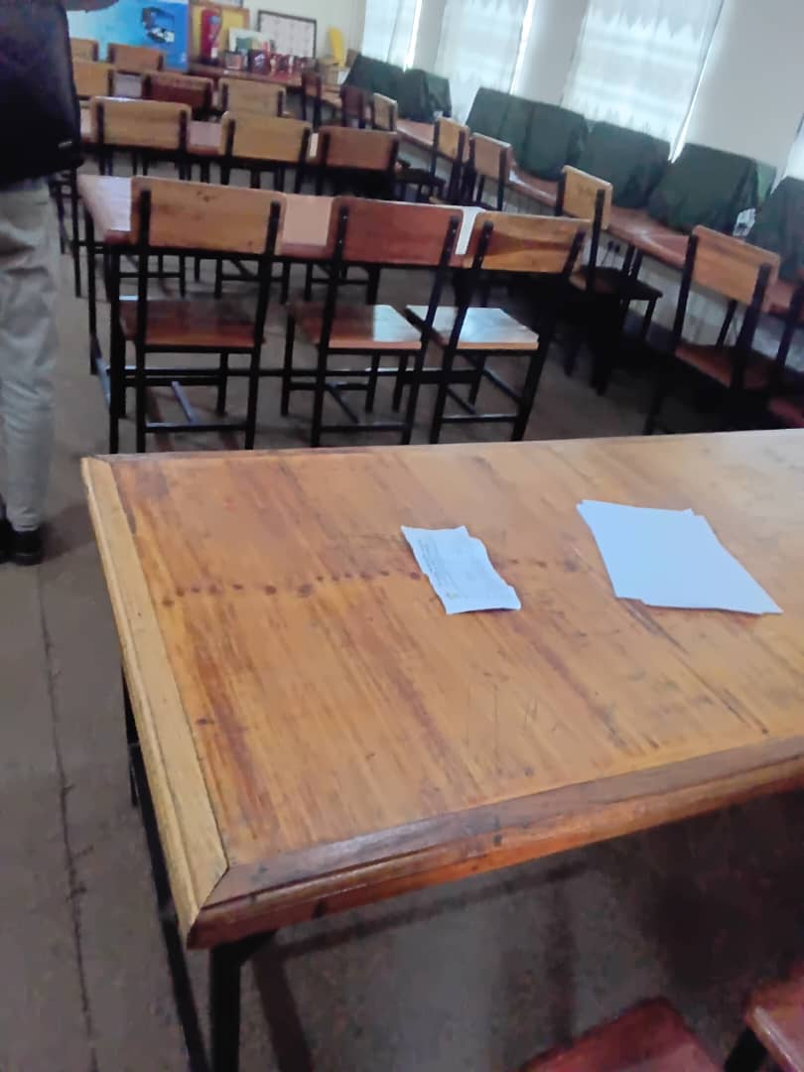
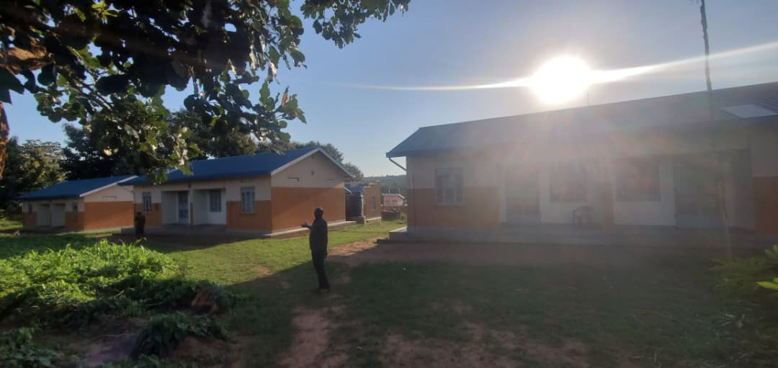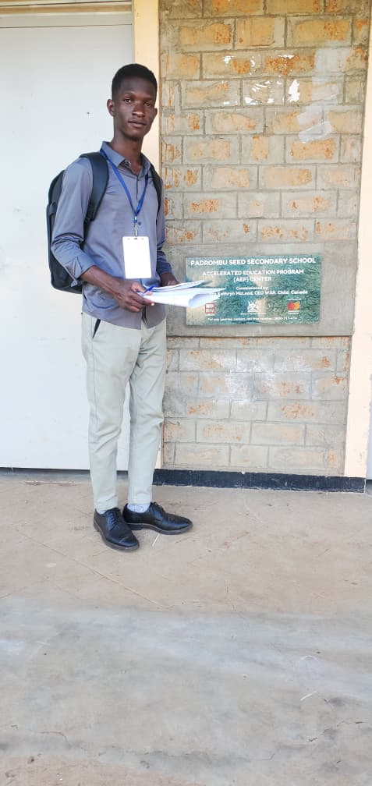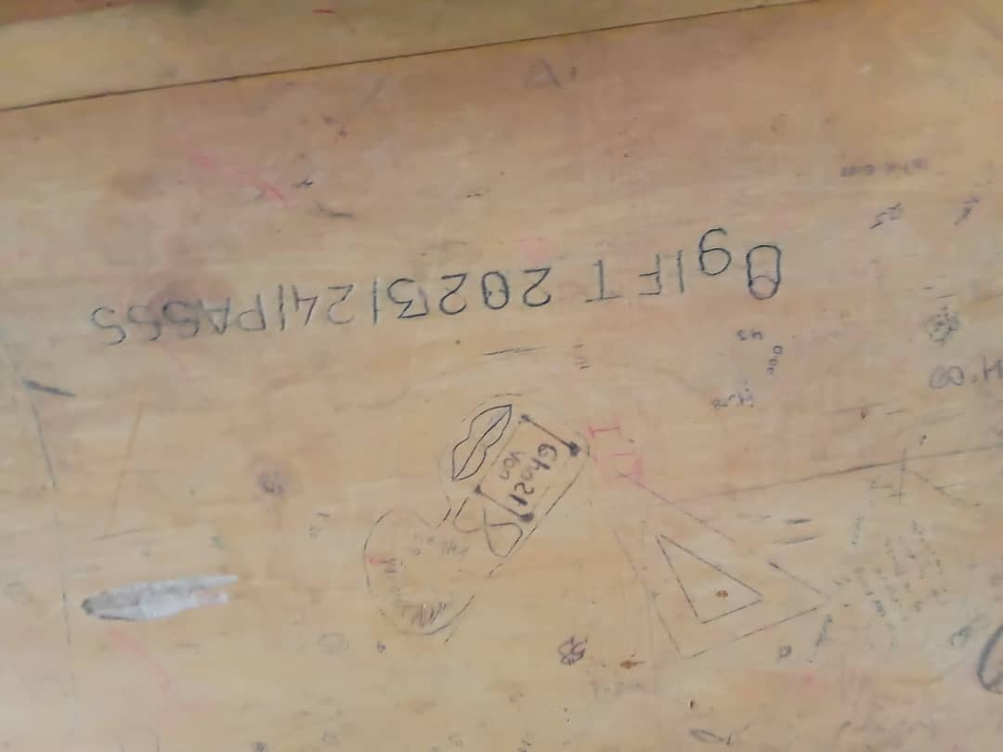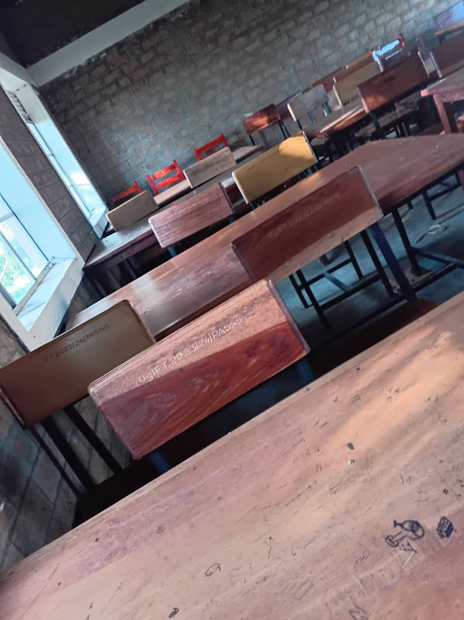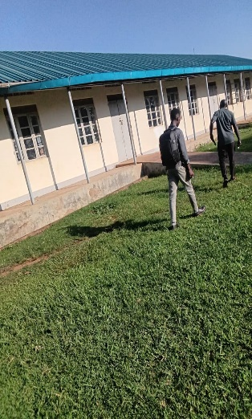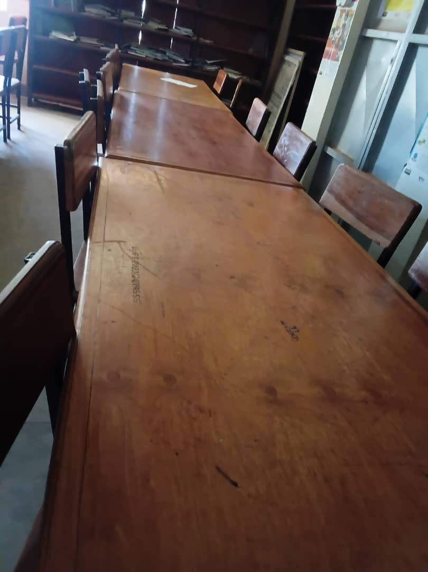
NYAKALISO SEED SECONDARY SCHOOL
The headteacher didn’t have records about the assets provided from ugift but the school had an inventory book
The headteacher took us around the school while we were verifying the assets

CHALLENGES
We didn’t have clear records to follow
The headteacher was not fully aware of ugift scope

RECOMMENDATIONS
Clear records should be kept to smoothen the verification process

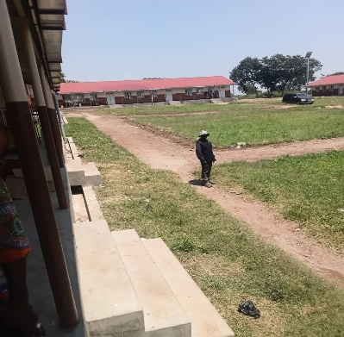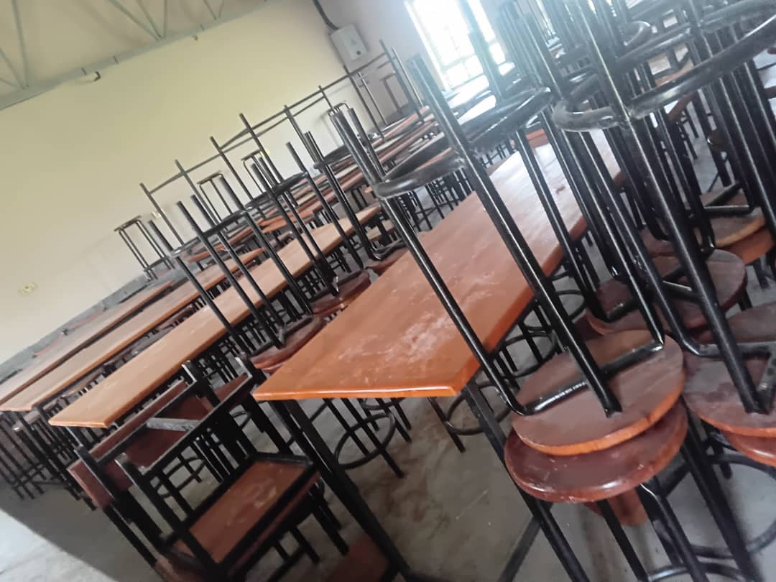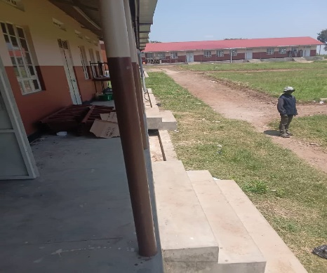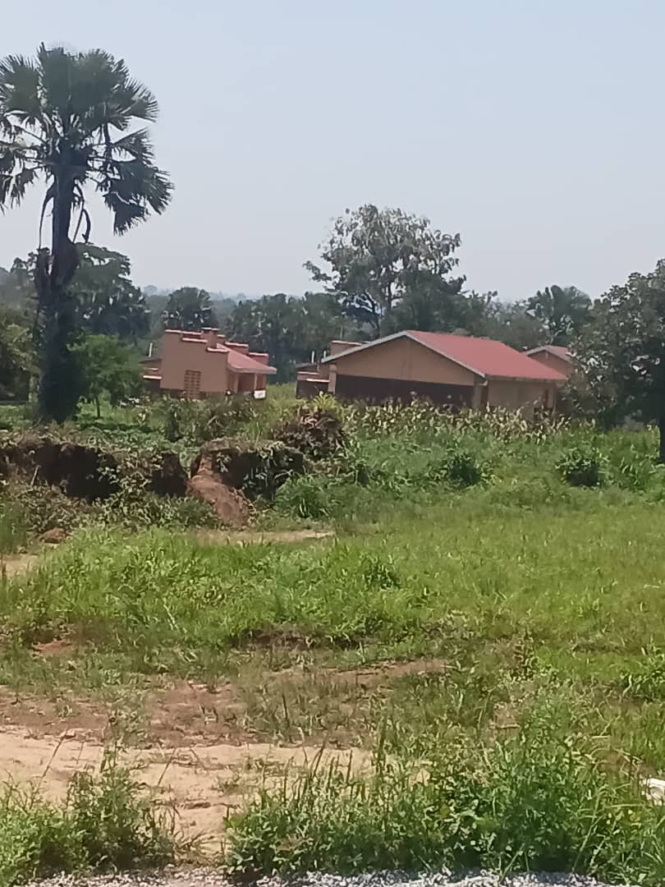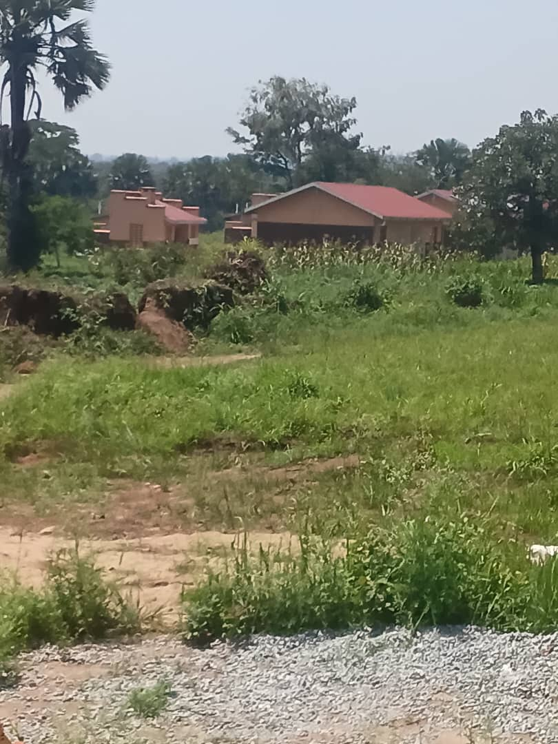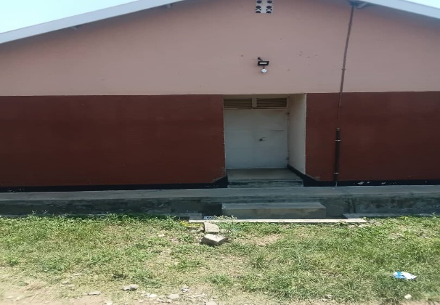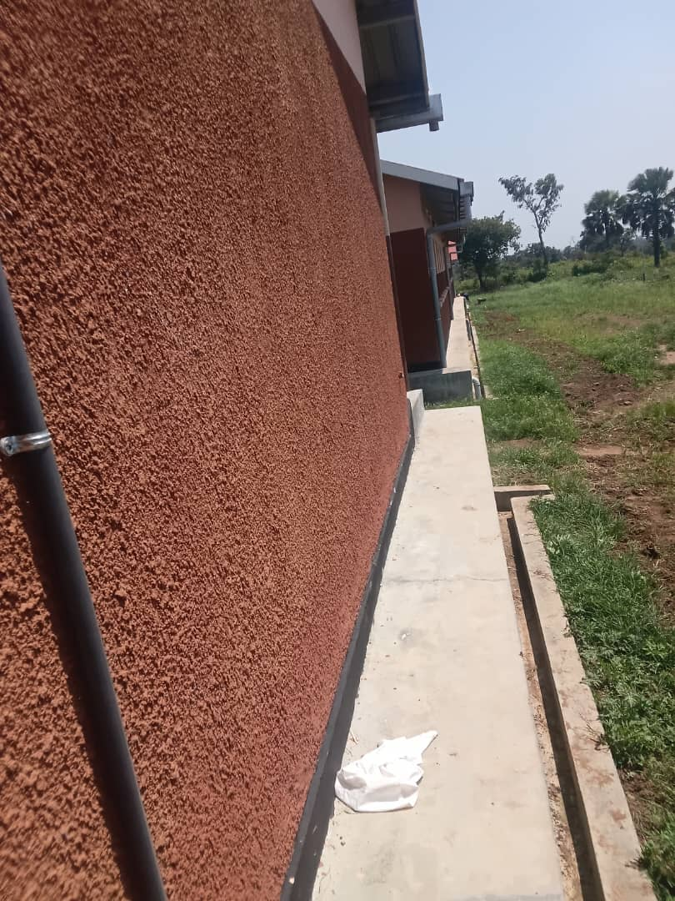

CHAKULIA HEALTH CENTER III
- The incharge received us and presented to us the delivery notes and the inventory records kept which eased work at the facility
- We had a guided tour through the facility and verified the different assets
- All assets were engraved with the same mark “CH/CIII”

CHALLENGES
Though they had the records, they were scattered and not organized

RECOMMENDATIONS
Good records keeping should be practiced to ease the assets verification program
